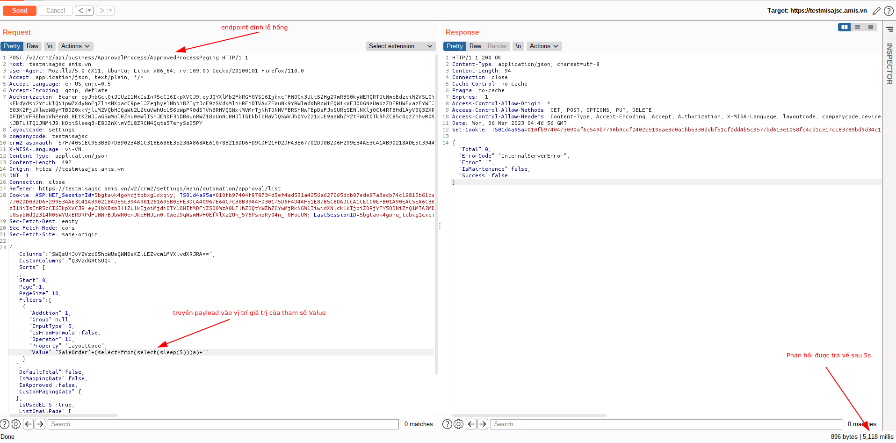
S
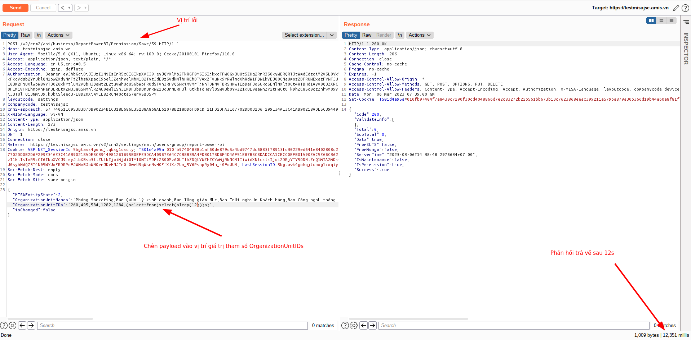
s
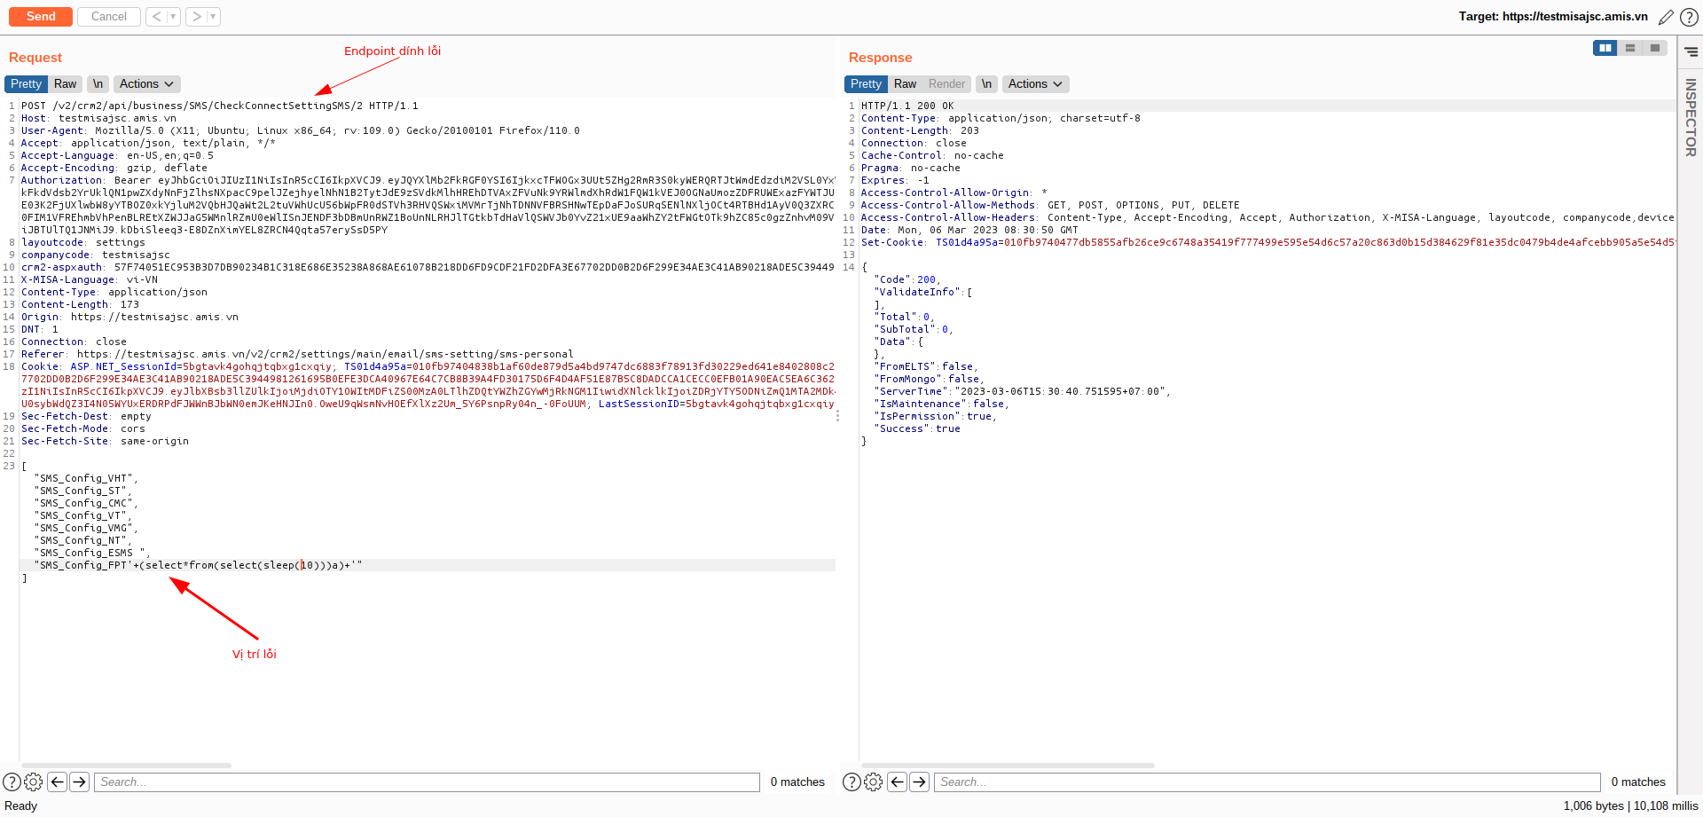
s
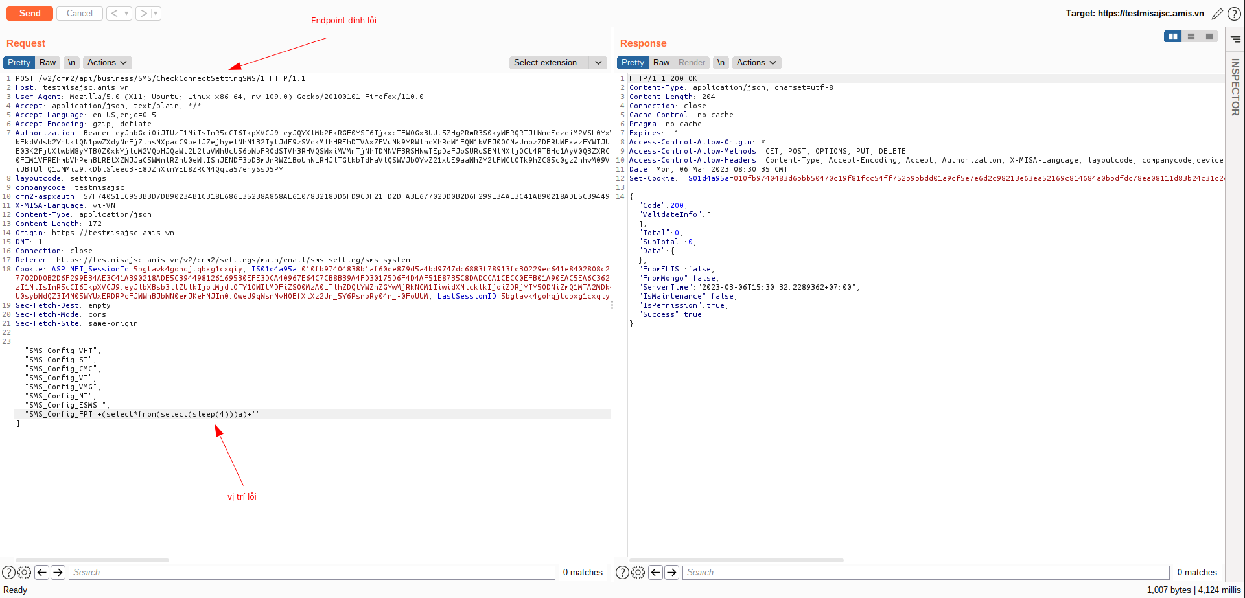
s

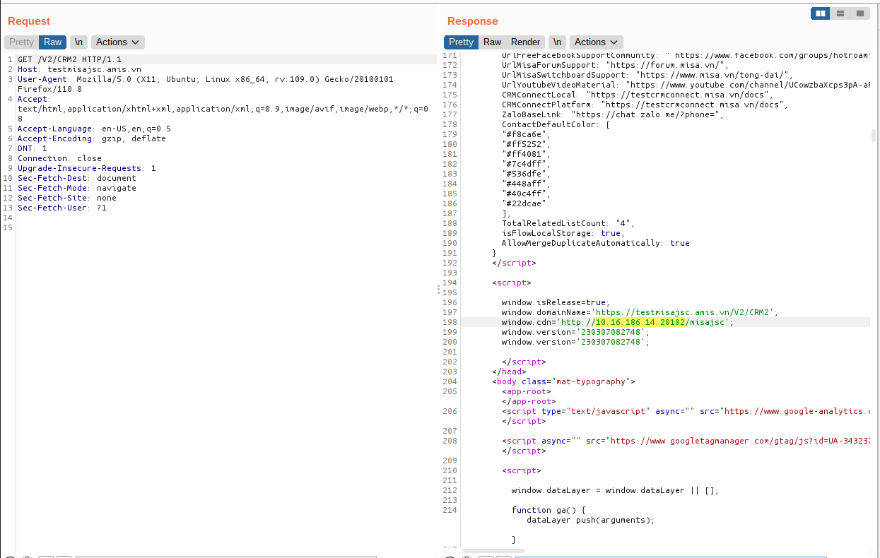
https://testmisajsc.amis.vn/V2/CRM2

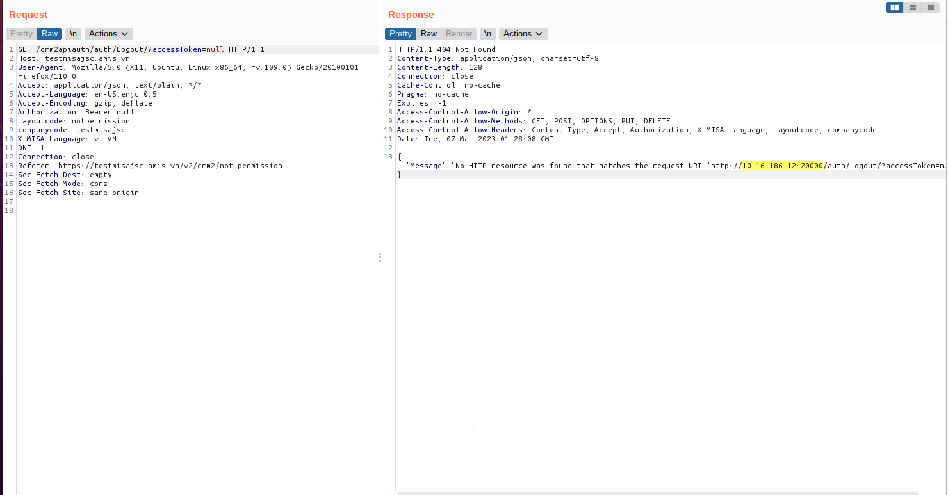
s
https://testmisajsc.amis.vn/crm2apiauth/auth/Logout/?accessToken=null

Danh sách URL đã pentest:
https://testmisajsc.amis.vn/
https://testmisajsc.amis.vn/APIS/AuthenAPI/api/Account/login
https://testmisajsc.amis.vn/favicon.ico?v=20230210_171412
https://testmisajsc.amis.vn/login
https://testmisajsc.amis.vn/v2/crm2/account/view/5783870/28
https://testmisajsc.amis.vn/v2/crm2/account/view/5783870/28?link=edited
https://testmisajsc.amis.vn/v2/crm2/api/business/Account
https://testmisajsc.amis.vn/v2/crm2/api/business/Account/CheckDuplicate?layoutCode=Account&masterID=5783870
https://testmisajsc.amis.vn/v2/crm2/api/business/Account/CrossSales/5783870
https://testmisajsc.amis.vn/v2/crm2/api/business/Account/SharingDatas/Account/5783870/2
https://testmisajsc.amis.vn/v2/crm2/api/business/AccountRanking/Config
https://testmisajsc.amis.vn/v2/crm2/api/business/Activity/FormConfig/Event/null/1
https://testmisajsc.amis.vn/v2/crm2/api/business/Activity/FormData/Event/null/1
https://testmisajsc.amis.vn/v2/crm2/api/business/ApprovalProcess/ApprovedProcessPaging
https://testmisajsc.amis.vn/v2/crm2/api/business/bussinesscard/Lead/51/null/getData
https://testmisajsc.amis.vn/v2/crm2/api/business/bussinesscard/OpportunityPool/62/null/getData
https://testmisajsc.amis.vn/v2/crm2/api/business/Common/VerifyTagCaching
https://testmisajsc.amis.vn/v2/crm2/api/business/Contact/CheckDuplicate?layoutCode=Contact&masterID=3495805
https://testmisajsc.amis.vn/v2/crm2/api/business/Contact/SharingDatas/Contact/3495805/2
https://testmisajsc.amis.vn/v2/crm2/api/business/CrossSales/Grid
https://testmisajsc.amis.vn/v2/crm2/api/business/Dashboard/SaleEmployee/ReportAnalyzeSalesByUnit
https://testmisajsc.amis.vn/v2/crm2/api/business/Dashboard/SaleManager/ReportManagerRevenueTime
https://testmisajsc.amis.vn/v2/crm2/api/business/Dashboard/SaleManager/ReportRevenueByProduct
https://testmisajsc.amis.vn/v2/crm2/api/business/Dashboard/SaleManager/ReportTopSellingProduct
https://testmisajsc.amis.vn/v2/crm2/api/business/Dictionary/Details/Lead/FormLayoutID/false/null/null/null?page=1&searchText=s&isLocationConcat=true&isContainFormLayoutName=true&isProductCustomField=false
https://testmisajsc.amis.vn/v2/crm2/api/business/Dictionary/Details/Lead/GenderID/false/null/null/null?page=1&searchText=&isLocationConcat=true&isContainFormLayoutName=true&isProductCustomField=false
https://testmisajsc.amis.vn/v2/crm2/api/business/Dictionary/DetailsUsed/Account/RatingID/false/null/null/null
https://testmisajsc.amis.vn/v2/crm2/api/business/documentTemplate/GetDocumentTemplateByLayoutCode/All/3
https://testmisajsc.amis.vn/v2/crm2/api/business/documentTemplate/GetDocumentTemplateByLayoutCode/Contact/1
https://testmisajsc.amis.vn/v2/crm2/api/business/documentTemplate/GetDocumentTemplateByLayoutCode/Lead/1
https://testmisajsc.amis.vn/v2/crm2/api/business/Email/CheckAuthorize
https://testmisajsc.amis.vn/v2/crm2/api/business/Email/CheckConnectSettingEmail
https://testmisajsc.amis.vn/v2/crm2/api/business/Email/CheckEmailSetting
https://testmisajsc.amis.vn/v2/crm2/api/business/Email/GetEmailSetting
https://testmisajsc.amis.vn/v2/crm2/api/business/Email/GetEmailSignatureByUserID
https://testmisajsc.amis.vn/v2/crm2/api/business/Email/ListProviderByType/1/false
https://testmisajsc.amis.vn/v2/crm2/api/business/gridlayout/getMassLayout/Lead
https://testmisajsc.amis.vn/v2/crm2/api/business/group/grid
https://testmisajsc.amis.vn/v2/crm2/api/business/HistoryDeal/GetHistoryDeal/Account/5783870/0/false
https://testmisajsc.amis.vn/v2/crm2/api/business/HistoryDeal/GetHistoryDeal/Contact/3495805/0/false
https://testmisajsc.amis.vn/v2/crm2/api/business/Lead/CheckDuplicate
https://testmisajsc.amis.vn/v2/crm2/api/business/Lead/CheckDuplicate?layoutCode=Lead&masterID=4793531
https://testmisajsc.amis.vn/v2/crm2/api/business/Lead/Configs/Lead/2
https://testmisajsc.amis.vn/v2/crm2/api/business/Lead/FormData/Lead/51/4
https://testmisajsc.amis.vn/v2/crm2/api/business/Lead/GetCustomComboField
https://testmisajsc.amis.vn/v2/crm2/api/business/Lead/grid
https://testmisajsc.amis.vn/v2/crm2/api/business/Lead/SharingDatas/Lead/4793531/2
https://testmisajsc.amis.vn/v2/crm2/api/business/Lead/ValidateApprovedProcess/Lead
https://testmisajsc.amis.vn/v2/crm2/api/business/Opportunity/Grid
https://testmisajsc.amis.vn/v2/crm2/api/business/OrganizationUnit/GetOrganizationUnitDetails/382
https://testmisajsc.amis.vn/v2/crm2/api/business/ProcessWriteRevenue/ProcessWriteRevenuePaging
https://testmisajsc.amis.vn/v2/crm2/api/business/product/GetProductPurchased
https://testmisajsc.amis.vn/v2/crm2/api/business/relatedlist/GetCustomRelatedListDataActivity/4793531/Lead
https://testmisajsc.amis.vn/v2/crm2/api/business/relatedlist/GetRelatedListByUser/681068/OpportunityPool
https://testmisajsc.amis.vn/v2/crm2/api/business/ReportPowerBI/Permission/Save/59
https://testmisajsc.amis.vn/v2/crm2/api/business/ScoreRuleCategory/GetScoreRuleCategories/Contact
https://testmisajsc.amis.vn/v2/crm2/api/business/ShareData/GetListShareDataRule
https://testmisajsc.amis.vn/v2/crm2/api/business/SMS/CheckConnectSettingSMS/1
https://testmisajsc.amis.vn/v2/crm2/api/business/SMS/CheckConnectSettingSMS/2
https://testmisajsc.amis.vn/v2/crm2/api/business/SMS/GetInfoBrand
https://testmisajsc.amis.vn/v2/crm2/api/business/SMS/ListProviderByRoleType/3/1/false
https://testmisajsc.amis.vn/v2/crm2/api/business/SMS/ListProviderByRoleType/3/2/false
https://testmisajsc.amis.vn/v2/crm2/api/business/SMS/SMSHistory?layoutCode=Lead&masterID=4793531
https://testmisajsc.amis.vn/v2/crm2/api/business/StageProbability/GetUnUsedFieldsList
https://testmisajsc.amis.vn/v2/crm2/api/business/Stock/false/true
https://testmisajsc.amis.vn/v2/crm2/api/business/Subscription/Grid
https://testmisajsc.amis.vn/v2/crm2/api/business/WorkFlow/list
https://testmisajsc.amis.vn/v2/crm2/api/common/Locations/search/1/1
https://testmisajsc.amis.vn/v2/crm2/api/common/Locations/search/2/1
https://testmisajsc.amis.vn/v2/crm2/api/common/Locations/search/3/1
https://testmisajsc.amis.vn/v2/crm2/lead/list
https://testmisajsc.amis.vn/v2/favicon.ico?v=230306103453
https://testmisajsc.amis.vn/v2/Login.aspx?ReturnUrl=%2fV2%2f
https://testmisajsc.amis.vn/V2/WebService/ProcessData.asmx/GetUserSetting?time=0603202325233PM
https://testmisajsc.amis.vn/V2/WebService/ProcessData.asmx/LoadWall?time=0603202327026PM
https://testmisajsc.amis.vn/v2/crm2
https://testmisajsc.amis.vn/v2/crm2/account/view/282089/null
https://testmisajsc.amis.vn/v2/crm2/api/business/Account/127524/
https://testmisajsc.amis.vn/v2/crm2/api/business/Account/127524/?columns=Avatar;TaxCode;BudgetCode;ParentAccountIDText;OfficeEmail;AccountName;AccountNumber
https://testmisajsc.amis.vn/v2/crm2/api/business/Account/5783816/
https://testmisajsc.amis.vn/v2/crm2/api/business/Account/5783816/?columns=ID;Debt;DebtLimit
https://testmisajsc.amis.vn/v2/crm2/api/business/Account/AccountFiles
https://testmisajsc.amis.vn/v2/crm2/api/business/Account/AccountFiles?masterID=5783816&layoutMasterID=0
https://testmisajsc.amis.vn/v2/crm2/api/business/Account/CheckDuplicate
https://testmisajsc.amis.vn/v2/crm2/api/business/Account/CheckDuplicate?layoutCode=Account&masterID=5783773
https://testmisajsc.amis.vn/v2/crm2/api/business/Account/CheckDuplicate?layoutCode=Account&masterID=5783816
https://testmisajsc.amis.vn/v2/crm2/api/business/Account/Configs/Account/2
https://testmisajsc.amis.vn/v2/crm2/api/business/Account/Configs/Account/4
https://testmisajsc.amis.vn/v2/crm2/api/business/Account/CrossSales/5783773
https://testmisajsc.amis.vn/v2/crm2/api/business/Account/CrossSales/5783816
https://testmisajsc.amis.vn/v2/crm2/api/business/Account/DigitalSign
https://testmisajsc.amis.vn/v2/crm2/api/business/Account/DigitalSign?masterID=5783816
https://testmisajsc.amis.vn/v2/crm2/api/business/Account/FormConfig/Account/28/4
https://testmisajsc.amis.vn/v2/crm2/api/business/Account/FormConfig/Account/null/4
https://testmisajsc.amis.vn/v2/crm2/api/business/Account/FormData/Account/28/4
https://testmisajsc.amis.vn/v2/crm2/api/business/Account/FormData/Account/null/4
https://testmisajsc.amis.vn/v2/crm2/api/business/Account/FormDataQuickAdd/Account/null/1
https://testmisajsc.amis.vn/v2/crm2/api/business/Account/GetData/3/Account
https://testmisajsc.amis.vn/v2/crm2/api/business/Account/Grid
https://testmisajsc.amis.vn/v2/crm2/api/business/Account/SharingDatas/Account/5783773/2
https://testmisajsc.amis.vn/v2/crm2/api/business/Account/SharingDatas/Account/5783816/2
https://testmisajsc.amis.vn/v2/crm2/api/business/Account/summary
https://testmisajsc.amis.vn/v2/crm2/api/business/Activity/CheckDuplicate
https://testmisajsc.amis.vn/v2/crm2/api/business/Activity/CheckDuplicate?layoutCode=Activity&masterID=12037310
https://testmisajsc.amis.vn/v2/crm2/api/business/Activity/FormConfig/Activity/undefined/4
https://testmisajsc.amis.vn/v2/crm2/api/business/Activity/FormConfig/Call/null/1
https://testmisajsc.amis.vn/v2/crm2/api/business/Activity/FormConfig/Mission/null/1
https://testmisajsc.amis.vn/v2/crm2/api/business/Activity/FormData/Activity/undefined/4
https://testmisajsc.amis.vn/v2/crm2/api/business/Activity/FormData/Call/null/1
https://testmisajsc.amis.vn/v2/crm2/api/business/Activity/FormData/Mission/null/1
https://testmisajsc.amis.vn/v2/crm2/api/business/Activity/GetItemCountByContactID/5783794
https://testmisajsc.amis.vn/v2/crm2/api/business/Activity/Grid
https://testmisajsc.amis.vn/v2/crm2/api/business/Activity/itemscount
https://testmisajsc.amis.vn/v2/crm2/api/business/Activity/SharingDatas/Activity/12037310/2
https://testmisajsc.amis.vn/v2/crm2/api/business/Activity/summary
https://testmisajsc.amis.vn/v2/crm2/api/business/AiMarketing/Grid
https://testmisajsc.amis.vn/v2/crm2/api/business/api-connect/getConnection/testmisajsc
https://testmisajsc.amis.vn/v2/crm2/api/business/api/checkConnectAImarketing
https://testmisajsc.amis.vn/v2/crm2/api/business/Attachment/grid
https://testmisajsc.amis.vn/v2/crm2/api/business/AuditingLog/Grid
https://testmisajsc.amis.vn/v2/crm2/api/business/bussinesscard/Campaign/12/null/getData
https://testmisajsc.amis.vn/v2/crm2/api/business/bussinesscard/Contact/13/null/getData
https://testmisajsc.amis.vn/v2/crm2/api/business/bussinesscard/Opportunity/141/null/getData
https://testmisajsc.amis.vn/v2/crm2/api/business/bussinesscard/ProductCategory/46/null/getData
https://testmisajsc.amis.vn/v2/crm2/api/business/bussinesscard/Quote/44/null/getData
https://testmisajsc.amis.vn/v2/crm2/api/business/bussinesscard/SaleOrder/37/null/getData
https://testmisajsc.amis.vn/v2/crm2/api/business/bussinesscard/SupportTicket/138/null/getData
https://testmisajsc.amis.vn/v2/crm2/api/business/Calendar/CalendarConfig
https://testmisajsc.amis.vn/v2/crm2/api/business/Calendar/GetCalendar
https://testmisajsc.amis.vn/v2/crm2/api/business/Campaign/CheckDuplicate
https://testmisajsc.amis.vn/v2/crm2/api/business/Campaign/CheckDuplicate?layoutCode=Campaign&masterID=166347
https://testmisajsc.amis.vn/v2/crm2/api/business/Campaign/CheckParentCampaign/166347
https://testmisajsc.amis.vn/v2/crm2/api/business/Campaign/Configs/Campaign/2
https://testmisajsc.amis.vn/v2/crm2/api/business/Campaign/Configs/Campaign/4
https://testmisajsc.amis.vn/v2/crm2/api/business/Campaign/Customers/166347
https://testmisajsc.amis.vn/v2/crm2/api/business/Campaign/FormData/Campaign/12/4
https://testmisajsc.amis.vn/v2/crm2/api/business/Campaign/GetListChildrenCampaign/166347
https://testmisajsc.amis.vn/v2/crm2/api/business/Campaign/GetReportRevenueGeneral/166347
https://testmisajsc.amis.vn/v2/crm2/api/business/Campaign/grid
https://testmisajsc.amis.vn/v2/crm2/api/business/Campaign/report/166347
https://testmisajsc.amis.vn/v2/crm2/api/business/Campaign/SharingDatas/Campaign/166347/2
https://testmisajsc.amis.vn/v2/crm2/api/business/Campaign/summary
https://testmisajsc.amis.vn/v2/crm2/api/business/Common/CheckEmpty/Account
https://testmisajsc.amis.vn/v2/crm2/api/business/Common/CheckEmpty/Activity
https://testmisajsc.amis.vn/v2/crm2/api/business/Common/CheckEmpty/Campaign
https://testmisajsc.amis.vn/v2/crm2/api/business/Common/CheckEmpty/CareCampaign
https://testmisajsc.amis.vn/v2/crm2/api/business/Common/CheckEmpty/Contact
https://testmisajsc.amis.vn/v2/crm2/api/business/Common/CheckEmpty/InvoiceRequest
https://testmisajsc.amis.vn/v2/crm2/api/business/Common/CheckEmpty/Offer
https://testmisajsc.amis.vn/v2/crm2/api/business/Common/CheckEmpty/Opportunity
https://testmisajsc.amis.vn/v2/crm2/api/business/Common/CheckEmpty/PriceBook
https://testmisajsc.amis.vn/v2/crm2/api/business/Common/CheckEmpty/Product
https://testmisajsc.amis.vn/v2/crm2/api/business/Common/CheckEmpty/ProductCategory
https://testmisajsc.amis.vn/v2/crm2/api/business/Common/CheckEmpty/Quote
https://testmisajsc.amis.vn/v2/crm2/api/business/Common/CheckEmpty/SaleOrder
https://testmisajsc.amis.vn/v2/crm2/api/business/Common/CheckEmpty/TakeCareCampaign
https://testmisajsc.amis.vn/v2/crm2/api/business/Common/CheckEmpty/Ticket
https://testmisajsc.amis.vn/v2/crm2/api/business/Common/CheckModelData
https://testmisajsc.amis.vn/v2/crm2/api/business/Common/EmployeesToolSupport
https://testmisajsc.amis.vn/v2/crm2/api/business/Common/GetDBOptionByKey/Common_MultiCurrency
https://testmisajsc.amis.vn/v2/crm2/api/business/Common/GetDBOptionByKey/DistanceCheckInRouting
https://testmisajsc.amis.vn/v2/crm2/api/business/Contact/3508263/
https://testmisajsc.amis.vn/v2/crm2/api/business/Contact/3508263/?columns=FirstName;LastName;Email;OfficeTel;Mobile;AccountNameID;ContactCode;AccountNameIDText;CreatedDate;ModifiedDate
https://testmisajsc.amis.vn/v2/crm2/api/business/Contact/CheckDuplicate
https://testmisajsc.amis.vn/v2/crm2/api/business/Contact/CheckDuplicate?layoutCode=Contact&masterID=3508263
https://testmisajsc.amis.vn/v2/crm2/api/business/Contact/Configs/Contact/2
https://testmisajsc.amis.vn/v2/crm2/api/business/Contact/Configs/Contact/4
https://testmisajsc.amis.vn/v2/crm2/api/business/Contact/FormData/Contact/13/4
https://testmisajsc.amis.vn/v2/crm2/api/business/Contact/Grid
https://testmisajsc.amis.vn/v2/crm2/api/business/Contact/grid
https://testmisajsc.amis.vn/v2/crm2/api/business/Contact/RemoveContactType/IsInvoiceContact/9978483
https://testmisajsc.amis.vn/v2/crm2/api/business/Contact/SaveContactType/IsInvoiceContact/5783816/9978483
https://testmisajsc.amis.vn/v2/crm2/api/business/Contact/SharingDatas/Contact/3508263/2
https://testmisajsc.amis.vn/v2/crm2/api/business/Contact/summary
https://testmisajsc.amis.vn/v2/crm2/api/business/Contact/ValidateApprovedProcess/Contact
https://testmisajsc.amis.vn/v2/crm2/api/business/conversation/GetConversationsByID/Activity/12037310
https://testmisajsc.amis.vn/v2/crm2/api/business/conversation/GetConversationsByID/OpportunityPool/681067
https://testmisajsc.amis.vn/v2/crm2/api/business/convert/case
https://testmisajsc.amis.vn/v2/crm2/api/business/Dashboard/SaleEmployee/GetReportExcellentStaff
https://testmisajsc.amis.vn/v2/crm2/api/business/Dashboard/SaleManager/GetReportStateEffectuateSaleForecast
https://testmisajsc.amis.vn/v2/crm2/api/business/Dashboard/SaleManager/ReportActivityCompletedStatus
https://testmisajsc.amis.vn/v2/crm2/api/business/Dashboard/SaleManager/ReportManagerExpectedAmountStatus
https://testmisajsc.amis.vn/v2/crm2/api/business/Dashboard/SaleManager/ReportManagerTargetRevenueTime
https://testmisajsc.amis.vn/v2/crm2/api/business/Dashboard/SaleManager/ReportOverview
https://testmisajsc.amis.vn/v2/crm2/api/business/DBOption/otherConfig
https://testmisajsc.amis.vn/v2/crm2/api/business/Dictionary/Details/Product/TaxID/false/null/null/null
https://testmisajsc.amis.vn/v2/crm2/api/business/Dictionary/Details/Product/TaxID/false/null/null/null?page=null&searchText=&isLocationConcat=false&isContainFormLayoutName=true&isProductCustomField=false
https://testmisajsc.amis.vn/v2/crm2/api/business/DynamicDashboard/getLayoutsByUserID/null
https://testmisajsc.amis.vn/v2/crm2/api/business/Email/checkEmailConnect
https://testmisajsc.amis.vn/v2/crm2/api/business/Email/CheckEmailSettingForSingleEmail
https://testmisajsc.amis.vn/v2/crm2/api/business/EmailPOP3IMAP/List
https://testmisajsc.amis.vn/v2/crm2/api/business/EmailPOP3IMAP/list
https://testmisajsc.amis.vn/v2/crm2/api/business/employee/crmpic
https://testmisajsc.amis.vn/v2/crm2/api/business/employee/GetEmployeeName
https://testmisajsc.amis.vn/v2/crm2/api/business/employee/OwnerGridPaging
https://testmisajsc.amis.vn/v2/crm2/api/business/Forecast/Data/Grid
https://testmisajsc.amis.vn/v2/crm2/api/business/FormLayout/Count/InvoiceRequest
https://testmisajsc.amis.vn/v2/crm2/api/business/FormLayout/Count/SaleOrder
https://testmisajsc.amis.vn/v2/crm2/api/business/FormLayout/Count/Ticket
https://testmisajsc.amis.vn/v2/crm2/api/business/gridlayout/default/Campaign
https://testmisajsc.amis.vn/v2/crm2/api/business/gridlayout/default/Contact
https://testmisajsc.amis.vn/v2/crm2/api/business/gridlayout/default/Quote
https://testmisajsc.amis.vn/v2/crm2/api/business/gridlayout/default/Routing
https://testmisajsc.amis.vn/v2/crm2/api/business/gridlayout/FieldsQuickSearch/Activity
https://testmisajsc.amis.vn/v2/crm2/api/business/gridlayout/FieldsQuickSearch/Campaign
https://testmisajsc.amis.vn/v2/crm2/api/business/gridlayout/FieldsQuickSearch/Offer
https://testmisajsc.amis.vn/v2/crm2/api/business/gridlayout/FieldsQuickSearch/PriceBook
https://testmisajsc.amis.vn/v2/crm2/api/business/gridlayout/FieldsQuickSearch/Product
https://testmisajsc.amis.vn/v2/crm2/api/business/gridlayout/FieldsQuickSearch/ProductCategory
https://testmisajsc.amis.vn/v2/crm2/api/business/gridlayout/FieldsQuickSearch/Routing
https://testmisajsc.amis.vn/v2/crm2/api/business/gridlayout/getMassLayout/Contact
https://testmisajsc.amis.vn/v2/crm2/api/business/haravan/GetHaravanAccount
https://testmisajsc.amis.vn/v2/crm2/api/business/HistoryDeal/GetHistoryDeal/Account/382988/0/false
https://testmisajsc.amis.vn/v2/crm2/api/business/HistoryDeal/GetHistoryDeal/Account/4526915/0/false
https://testmisajsc.amis.vn/v2/crm2/api/business/HistoryDeal/GetHistoryDeal/Account/5783816/0/false
https://testmisajsc.amis.vn/v2/crm2/api/business/HistoryDeal/GetHistoryDeal/Account/5783855/0/false
https://testmisajsc.amis.vn/v2/crm2/api/business/HistoryDeal/GetHistoryDeal/Contact/3508263/0/false
https://testmisajsc.amis.vn/v2/crm2/api/business/HistoryDeal/GetHistoryDeal/Contact/3508263/1/false
https://testmisajsc.amis.vn/v2/crm2/api/business/HistoryDeal/GetHistoryDeal/Lead/4799166/0/false
https://testmisajsc.amis.vn/v2/crm2/api/business/HistoryDeal/GetHistoryDeal/Opportunity/1949133/0/false
https://testmisajsc.amis.vn/v2/crm2/api/business/HistoryDeal/GetHistoryDeal/Opportunity/1949133/1/false
https://testmisajsc.amis.vn/v2/crm2/api/business/HistoryDeal/GetHistoryDeal/Opportunity/1949133/3/false
https://testmisajsc.amis.vn/v2/crm2/api/business/HistorySendSMS/Configs/HistorySendSMS/4
https://testmisajsc.amis.vn/v2/crm2/api/business/HistorySendSMS/Grid
https://testmisajsc.amis.vn/v2/crm2/api/business/HistorySendSMS/summary
https://testmisajsc.amis.vn/v2/crm2/api/business/InvoiceRequest/CheckDuplicate
https://testmisajsc.amis.vn/v2/crm2/api/business/InvoiceRequest/CheckDuplicate?layoutCode=InvoiceRequest&masterID=840662
https://testmisajsc.amis.vn/v2/crm2/api/business/InvoiceRequest/CheckDuplicate?layoutCode=InvoiceRequest&masterID=840664
https://testmisajsc.amis.vn/v2/crm2/api/business/InvoiceRequest/Configs/InvoiceRequest/2
https://testmisajsc.amis.vn/v2/crm2/api/business/InvoiceRequest/Configs/InvoiceRequest/4
https://testmisajsc.amis.vn/v2/crm2/api/business/InvoiceRequest/FormConfig/InvoiceRequest/0/1
https://testmisajsc.amis.vn/v2/crm2/api/business/InvoiceRequest/FormConfig/InvoiceRequest/43/4
https://testmisajsc.amis.vn/v2/crm2/api/business/InvoiceRequest/FormConfig/InvoiceRequest/undefined/1
https://testmisajsc.amis.vn/v2/crm2/api/business/InvoiceRequest/FormData/InvoiceRequest/0/1
https://testmisajsc.amis.vn/v2/crm2/api/business/InvoiceRequest/FormData/InvoiceRequest/43/4
https://testmisajsc.amis.vn/v2/crm2/api/business/InvoiceRequest/FormData/InvoiceRequest/undefined/1
https://testmisajsc.amis.vn/v2/crm2/api/business/InvoiceRequest/GetData/3/InvoiceRequest
https://testmisajsc.amis.vn/v2/crm2/api/business/InvoiceRequest/Grid
https://testmisajsc.amis.vn/v2/crm2/api/business/InvoiceRequest/SharingDatas/InvoiceRequest/840662/2
https://testmisajsc.amis.vn/v2/crm2/api/business/InvoiceRequest/SharingDatas/InvoiceRequest/840664/2
https://testmisajsc.amis.vn/v2/crm2/api/business/InvoiceRequest/summary
https://testmisajsc.amis.vn/v2/crm2/api/business/Location/detail/VN
https://testmisajsc.amis.vn/v2/crm2/api/business/Mapping/GetContactIDRelatedToAccount/5783816
https://testmisajsc.amis.vn/v2/crm2/api/business/MCP/GetDataMCPByTaxtCode
https://testmisajsc.amis.vn/v2/crm2/api/business/Note/list
https://testmisajsc.amis.vn/v2/crm2/api/business/Notification/getNotificationPaging
https://testmisajsc.amis.vn/v2/crm2/api/business/Offer/Grid
https://testmisajsc.amis.vn/v2/crm2/api/business/Offer/ItemsCountAll
https://testmisajsc.amis.vn/v2/crm2/api/business/Offer/summary
https://testmisajsc.amis.vn/v2/crm2/api/business/Opportunity/CheckDuplicate
https://testmisajsc.amis.vn/v2/crm2/api/business/Opportunity/CheckDuplicate?layoutCode=Opportunity&masterID=1949133
https://testmisajsc.amis.vn/v2/crm2/api/business/Opportunity/Configs/Opportunity/2
https://testmisajsc.amis.vn/v2/crm2/api/business/Opportunity/Configs/Opportunity/4
https://testmisajsc.amis.vn/v2/crm2/api/business/Opportunity/GetData/3/Opportunity
https://testmisajsc.amis.vn/v2/crm2/api/business/Opportunity/GetDataSubFormByID/1949133/2/false
https://testmisajsc.amis.vn/v2/crm2/api/business/Opportunity/GetFormLayoutHCSN
https://testmisajsc.amis.vn/v2/crm2/api/business/Opportunity/GetFormLayoutQuickView
https://testmisajsc.amis.vn/v2/crm2/api/business/Opportunity/grid
https://testmisajsc.amis.vn/v2/crm2/api/business/Opportunity/SharingDatas/Opportunity/1949133/2
https://testmisajsc.amis.vn/v2/crm2/api/business/Opportunity/summary
https://testmisajsc.amis.vn/v2/crm2/api/business/Opportunity/ValidateApprovedProcess/Opportunity
https://testmisajsc.amis.vn/v2/crm2/api/business/OpportunityPool/680921/
https://testmisajsc.amis.vn/v2/crm2/api/business/OpportunityPool/680921/?columns=RelatedUsersID;RelatedUsersIDText
https://testmisajsc.amis.vn/v2/crm2/api/business/OpportunityPool/681067/
https://testmisajsc.amis.vn/v2/crm2/api/business/OpportunityPool/681067/?columns=RelatedUsersID;RelatedUsersIDText
https://testmisajsc.amis.vn/v2/crm2/api/business/OpportunityPool/Configs/OpportunityPool/2
https://testmisajsc.amis.vn/v2/crm2/api/business/OpportunityPool/FormConfig/OpportunityPool/62/4
https://testmisajsc.amis.vn/v2/crm2/api/business/OpportunityPool/FormConfig/OpportunityPool/undefined/4
https://testmisajsc.amis.vn/v2/crm2/api/business/OpportunityPool/FormData/OpportunityPool/62/4
https://testmisajsc.amis.vn/v2/crm2/api/business/OpportunityPool/FormData/OpportunityPool/undefined/4
https://testmisajsc.amis.vn/v2/crm2/api/business/OpportunityPool/grid
https://testmisajsc.amis.vn/v2/crm2/api/business/OpportunityPool/SharingDatas/OpportunityPool/681068/2
https://testmisajsc.amis.vn/v2/crm2/api/business/OrganizationUnit/EmployeeAccessLevel/false/false
https://testmisajsc.amis.vn/v2/crm2/api/business/OrganizationUnit/EmployeeAccessLevel/true/false
https://testmisajsc.amis.vn/v2/crm2/api/business/OrganizationUnit/GetMaxParrentOrganizationUnit
https://testmisajsc.amis.vn/v2/crm2/api/business/OrganizationUnit/GetOrganizationUnitByEmployeeAccessLevel/Tree/true
https://testmisajsc.amis.vn/v2/crm2/api/business/OrganizationUnit/GetOrganizationUnitByID/1
https://testmisajsc.amis.vn/v2/crm2/api/business/OrganizationUnit/GetOrgUnitIDAndChildrenBySessionUser
https://testmisajsc.amis.vn/v2/crm2/api/business/PriceBook/Configs/PriceBook/4
https://testmisajsc.amis.vn/v2/crm2/api/business/PriceBook/Grid
https://testmisajsc.amis.vn/v2/crm2/api/business/PriceBook/summary
https://testmisajsc.amis.vn/v2/crm2/api/business/Product/Configs/Product/4
https://testmisajsc.amis.vn/v2/crm2/api/business/Product/grid
https://testmisajsc.amis.vn/v2/crm2/api/business/Product/summary
https://testmisajsc.amis.vn/v2/crm2/api/business/ProductCategory/CheckDuplicate
https://testmisajsc.amis.vn/v2/crm2/api/business/ProductCategory/CheckDuplicate?layoutCode=ProductCategory&masterID=235
https://testmisajsc.amis.vn/v2/crm2/api/business/ProductCategory/Configs/EmailMarketing/2
https://testmisajsc.amis.vn/v2/crm2/api/business/ProductCategory/Configs/ProductCategory/2
https://testmisajsc.amis.vn/v2/crm2/api/business/ProductCategory/Configs/ProductCategory/4
https://testmisajsc.amis.vn/v2/crm2/api/business/ProductCategory/FormData/ProductCategory/46/4
https://testmisajsc.amis.vn/v2/crm2/api/business/ProductCategory/GetProductCategoryByCode/HCSN
https://testmisajsc.amis.vn/v2/crm2/api/business/ProductCategory/SharingDatas/ProductCategory/235/2
https://testmisajsc.amis.vn/v2/crm2/api/business/ProductCategory/summary
https://testmisajsc.amis.vn/v2/crm2/api/business/Quote/CheckDuplicate
https://testmisajsc.amis.vn/v2/crm2/api/business/Quote/CheckDuplicate?layoutCode=Quote&masterID=292
https://testmisajsc.amis.vn/v2/crm2/api/business/Quote/Configs/Quote/2
https://testmisajsc.amis.vn/v2/crm2/api/business/Quote/Configs/Quote/4
https://testmisajsc.amis.vn/v2/crm2/api/business/Quote/FormConfig/Quote/0/1
https://testmisajsc.amis.vn/v2/crm2/api/business/Quote/FormConfig/Quote/44/1
https://testmisajsc.amis.vn/v2/crm2/api/business/Quote/FormData/Quote/0/1
https://testmisajsc.amis.vn/v2/crm2/api/business/Quote/FormData/Quote/44/1
https://testmisajsc.amis.vn/v2/crm2/api/business/Quote/FormData/Quote/44/4
https://testmisajsc.amis.vn/v2/crm2/api/business/Quote/GetData/6/Quote
https://testmisajsc.amis.vn/v2/crm2/api/business/Quote/grid
https://testmisajsc.amis.vn/v2/crm2/api/business/Quote/SharingDatas/Quote/292/2
https://testmisajsc.amis.vn/v2/crm2/api/business/Quote/summary
https://testmisajsc.amis.vn/v2/crm2/api/business/RelatedList/GetCustomRelatedListData
https://testmisajsc.amis.vn/v2/crm2/api/business/RelatedList/GetCustomRelatedListData?id=3508263&layoutCode=Contact
https://testmisajsc.amis.vn/v2/crm2/api/business/relatedlist/GetCustomRelatedListDataActivity/1949133/Opportunity
https://testmisajsc.amis.vn/v2/crm2/api/business/relatedlist/GetCustomRelatedListDataActivity/3508263/Contact
https://testmisajsc.amis.vn/v2/crm2/api/business/relatedlist/GetCustomRelatedListDataActivity/5783816/Account
https://testmisajsc.amis.vn/v2/crm2/api/business/relatedlist/GetRelatedListByUser/235/ProductCategory
https://testmisajsc.amis.vn/v2/crm2/api/business/relatedlist/GetRelatedListByUser/840662/InvoiceRequest
https://testmisajsc.amis.vn/v2/crm2/api/business/relatedlist/GetRelatedListByUser/840664/InvoiceRequest
https://testmisajsc.amis.vn/v2/crm2/api/business/Report/GetAllDirectoryReport
https://testmisajsc.amis.vn/v2/crm2/api/business/report/getallreport/2
https://testmisajsc.amis.vn/v2/crm2/api/business/report/grid
https://testmisajsc.amis.vn/v2/crm2/api/business/Routing/Configs/Routing/4
https://testmisajsc.amis.vn/v2/crm2/api/business/Routing/grid
https://testmisajsc.amis.vn/v2/crm2/api/business/Routing/RoutingDefault
https://testmisajsc.amis.vn/v2/crm2/api/business/Routing/RoutingDefault?organizationUnitID=null
https://testmisajsc.amis.vn/v2/crm2/api/business/Routing/summary
https://testmisajsc.amis.vn/v2/crm2/api/business/SaleOrder/CheckDuplicate
https://testmisajsc.amis.vn/v2/crm2/api/business/SaleOrder/CheckDuplicate?layoutCode=SaleOrder&masterID=2278892
https://testmisajsc.amis.vn/v2/crm2/api/business/SaleOrder/Configs/Offer/4
https://testmisajsc.amis.vn/v2/crm2/api/business/SaleOrder/Configs/SaleOrder/2
https://testmisajsc.amis.vn/v2/crm2/api/business/SaleOrder/Configs/SaleOrder/4
https://testmisajsc.amis.vn/v2/crm2/api/business/SaleOrder/FormConfig/SaleOrder/0/1
https://testmisajsc.amis.vn/v2/crm2/api/business/SaleOrder/FormConfig/SaleOrder/37/1
https://testmisajsc.amis.vn/v2/crm2/api/business/SaleOrder/FormConfig/SaleOrder/undefined/1
https://testmisajsc.amis.vn/v2/crm2/api/business/SaleOrder/FormData/SaleOrder/0/1
https://testmisajsc.amis.vn/v2/crm2/api/business/SaleOrder/FormData/SaleOrder/37/1
https://testmisajsc.amis.vn/v2/crm2/api/business/SaleOrder/FormData/SaleOrder/37/4
https://testmisajsc.amis.vn/v2/crm2/api/business/SaleOrder/FormData/SaleOrder/undefined/1
https://testmisajsc.amis.vn/v2/crm2/api/business/SaleOrder/grid
https://testmisajsc.amis.vn/v2/crm2/api/business/SaleOrder/Grid
https://testmisajsc.amis.vn/v2/crm2/api/business/SaleOrder/SharingDatas/SaleOrder/2278892/2
https://testmisajsc.amis.vn/v2/crm2/api/business/SaleOrder/summary
https://testmisajsc.amis.vn/v2/crm2/api/business/SaleOrderActualReceipt/getActualReceiptByMasterID/2278892
https://testmisajsc.amis.vn/v2/crm2/api/business/SaleOrderRecordSale/GetBonusSaleRelatedPaging/2278892
https://testmisajsc.amis.vn/v2/crm2/api/business/SaleOrderRecordSale/getRecordSaleRelatedPaging/2278892
https://testmisajsc.amis.vn/v2/crm2/api/business/SaleOrderRecordSale/getRecordSaleRelatedPagingNumber/2278892
https://testmisajsc.amis.vn/v2/crm2/api/business/SaleOrderRecordSale/summary
https://testmisajsc.amis.vn/v2/crm2/api/business/SMS/SMSConfigRoleType/2
https://testmisajsc.amis.vn/v2/crm2/api/business/SMS/SMSHistory
https://testmisajsc.amis.vn/v2/crm2/api/business/SMS/SMSHistory?layoutCode=Contact&masterID=3508263
https://testmisajsc.amis.vn/v2/crm2/api/business/Stock/inventoryColumns/1
https://testmisajsc.amis.vn/v2/crm2/api/business/Stock/productLedger/Paging
https://testmisajsc.amis.vn/v2/crm2/api/business/SubscriptionInfomation
https://testmisajsc.amis.vn/v2/crm2/api/business/SupportTicket/CheckDuplicate
https://testmisajsc.amis.vn/v2/crm2/api/business/SupportTicket/CheckDuplicate?layoutCode=SupportTicket&masterID=21156
https://testmisajsc.amis.vn/v2/crm2/api/business/SupportTicket/Configs/SupportTicket/2
https://testmisajsc.amis.vn/v2/crm2/api/business/SupportTicket/Configs/SupportTicket/4
https://testmisajsc.amis.vn/v2/crm2/api/business/SupportTicket/SharingDatas/SupportTicket/21156/2
https://testmisajsc.amis.vn/v2/crm2/api/business/SupportTicket/summary
https://testmisajsc.amis.vn/v2/crm2/api/business/Tag/ProductCategory/GetAll
https://testmisajsc.amis.vn/v2/crm2/api/business/Ticket/Configs/Ticket/4
https://testmisajsc.amis.vn/v2/crm2/api/business/Ticket/FormConfig/Ticket/undefined/1
https://testmisajsc.amis.vn/v2/crm2/api/business/Ticket/FormData/Ticket/undefined/1
https://testmisajsc.amis.vn/v2/crm2/api/business/Ticket/Grid
https://testmisajsc.amis.vn/v2/crm2/api/business/Ticket/summary
https://testmisajsc.amis.vn/v2/crm2/api/business/TimeLine/Contact/GetAllHistoryByMasterID/3508263
https://testmisajsc.amis.vn/v2/crm2/api/business/VoiceIPSetting/GetVoiceIPSettingByProviderName/STelecom
https://testmisajsc.amis.vn/v2/crm2/api/business/webtoform/getListWebFormByLayoutCode/Lead
https://testmisajsc.amis.vn/v2/crm2/api/business/webtoform/getListWebFormByLayoutCode/Opportunity_Pool
https://testmisajsc.amis.vn/v2/favicon.ico?v=230303150155
https://testmisajsc.amis.vn/ACT/
https://testmisajsc.amis.vn/crm2apiauth/auth
https://testmisajsc.amis.vn/crm2apiauth/auth/Logout/
https://testmisajsc.amis.vn/Initiative/
https://testmisajsc.amis.vn/robots.txt
https://testmisajsc.amis.vn/V2/
https://testmisajsc.amis.vn/V2/AmisLicenseAgrement.aspx
https://testmisajsc.amis.vn/V2/Asset
https://testmisajsc.amis.vn/V2/Contact.aspx
https://testmisajsc.amis.vn/V2/CRM/
https://testmisajsc.amis.vn/V2/CRM2
https://testmisajsc.amis.vn/v2/crm2/api/business
https://testmisajsc.amis.vn/v2/crm2/api/business/Common/CheckEmpty/Lead
https://testmisajsc.amis.vn/v2/crm2/api/business/Common/CheckEmpty/OpportunityPool
https://testmisajsc.amis.vn/v2/crm2/api/business/Common/GetDBOptionByKey/PageSize_Grid/true
https://testmisajsc.amis.vn/v2/crm2/api/business/Common/UpdateDBOptionObject/true
https://testmisajsc.amis.vn/v2/crm2/api/business/conversation/GetConversationsByID/OpportunityPool/681068
https://testmisajsc.amis.vn/v2/crm2/api/business/Dashboard/GetOrganizationUnitInfor
https://testmisajsc.amis.vn/v2/crm2/api/business/Dictionary/Details/Lead/BusinessFormID/false/null/2/null
https://testmisajsc.amis.vn/v2/crm2/api/business/Dictionary/Details/Lead/BusinessFormID/false/null/2/null?page=1&searchText=&isLocationConcat=true&isContainFormLayoutName=true&isProductCustomField=false
https://testmisajsc.amis.vn/v2/crm2/api/business/Dictionary/Details/Lead/BusinessFormID/false/null/null/null
https://testmisajsc.amis.vn/v2/crm2/api/business/Dictionary/Details/Lead/BusinessFormID/false/null/null/null?page=1&searchText=&isLocationConcat=true&isContainFormLayoutName=true&isProductCustomField=false
https://testmisajsc.amis.vn/v2/crm2/api/business/Dictionary/Details/Lead/CompetitorID/false/null/null/null
https://testmisajsc.amis.vn/v2/crm2/api/business/Dictionary/Details/Lead/CompetitorID/false/null/null/null?page=1&searchText=&isLocationConcat=true&isContainFormLayoutName=true&isProductCustomField=false
https://testmisajsc.amis.vn/v2/crm2/api/business/Dictionary/Details/Lead/FormLayoutID/false/null/null/null
https://testmisajsc.amis.vn/v2/crm2/api/business/Dictionary/Details/Lead/FormLayoutID/false/null/null/null?page=1&searchText=&isLocationConcat=true&isContainFormLayoutName=true&isProductCustomField=false
https://testmisajsc.amis.vn/v2/crm2/api/business/Dictionary/Details/Lead/GenderID/false/null/null/null
https://testmisajsc.amis.vn/v2/crm2/api/business/Dictionary/Details/Lead/GenderID/false/null/null/null?page=1&searchText=a&isLocationConcat=true&isContainFormLayoutName=true&isProductCustomField=false
https://testmisajsc.amis.vn/v2/crm2/api/business/employee/pic
https://testmisajsc.amis.vn/v2/crm2/api/business/FormLayout/Code/Lead
https://testmisajsc.amis.vn/v2/crm2/api/business/FormLayout/Code/Opportunity
https://testmisajsc.amis.vn/v2/crm2/api/business/FormLayout/Count/Lead
https://testmisajsc.amis.vn/v2/crm2/api/business/HistoryDeal/GetHistoryDeal/Lead/4779151/0/false
https://testmisajsc.amis.vn/v2/crm2/api/business/HistoryDeal/GetHistoryDeal/Lead/4781686/0/false
https://testmisajsc.amis.vn/v2/crm2/api/business/HistoryDeal/GetHistoryDeal/Lead/4782656/0/false
https://testmisajsc.amis.vn/v2/crm2/api/business/HistoryDeal/GetHistoryDeal/Lead/4783124/0/false
https://testmisajsc.amis.vn/v2/crm2/api/business/HistoryDeal/GetHistoryDeal/Lead/4793531/0/false
https://testmisajsc.amis.vn/v2/crm2/api/business/HistoryDeal/GetHistoryDeal/Lead/4797586/0/false
https://testmisajsc.amis.vn/v2/crm2/api/business/HistoryDeal/GetHistoryDeal/Lead/4797647/0/false
https://testmisajsc.amis.vn/v2/crm2/api/business/HistoryDeal/GetHistoryDeal/Lead/4797716/0/false
https://testmisajsc.amis.vn/v2/crm2/api/business/HistoryDeal/GetHistoryDeal/Lead/4798470/0/false
https://testmisajsc.amis.vn/v2/crm2/api/business/HistoryDeal/GetHistoryDeal/Lead/4798984/0/false
https://testmisajsc.amis.vn/v2/crm2/api/business/HistoryDeal/GetHistoryDeal/Lead/4799163/0/false
https://testmisajsc.amis.vn/v2/crm2/api/business/Kanban
https://testmisajsc.amis.vn/v2/crm2/api/business/Kanban/KanbanFormLayout/Lead
https://testmisajsc.amis.vn/v2/crm2/api/business/Kanban/KanbanLayout/Lead
https://testmisajsc.amis.vn/v2/crm2/api/business/Kanban/SetupKanBan/Lead
https://testmisajsc.amis.vn/v2/crm2/api/business/Kanban/SortDataKanban/Lead
https://testmisajsc.amis.vn/v2/crm2/api/business/Lead/Configs/Lead/4
https://testmisajsc.amis.vn/v2/crm2/api/business/Lead/FormConfig/Lead/null/1
https://testmisajsc.amis.vn/v2/crm2/api/business/Lead/FormData/Lead/null/1
https://testmisajsc.amis.vn/v2/crm2/api/business/Lead/Grid
https://testmisajsc.amis.vn/v2/crm2/api/business/Lead/summary
https://testmisajsc.amis.vn/v2/crm2/api/business/Notification/getNotificationMonitor
https://testmisajsc.amis.vn/v2/crm2/api/business/Notification/newNotificationItemsCount
https://testmisajsc.amis.vn/v2/crm2/api/business/OpportunityPool/681068/
https://testmisajsc.amis.vn/v2/crm2/api/business/OpportunityPool/681068/?columns=RelatedUsersID;RelatedUsersIDText
https://testmisajsc.amis.vn/v2/crm2/api/business/OpportunityPool/Configs/OpportunityPool/4
https://testmisajsc.amis.vn/v2/crm2/api/business/OpportunityPool/Grid
https://testmisajsc.amis.vn/v2/crm2/api/business/OpportunityPool/summary
https://testmisajsc.amis.vn/v2/crm2/api/business/OrganizationUnit/GetOrgUnitIDAndChildren
https://testmisajsc.amis.vn/v2/crm2/api/business/OrganizationUnit/GetOrgUnitIDAndChildren?misaCode=0001/0001
https://testmisajsc.amis.vn/v2/crm2/api/business/relatedlist/GetFieldSearchByLayoutCode/Lead
https://testmisajsc.amis.vn/v2/crm2/api/business/Tag/TagPaging
https://testmisajsc.amis.vn/v2/crm2/api/business/UserConfig/InsertUserConfig
https://testmisajsc.amis.vn/v2/crm2/api/business/UserConfig/UpdateUserConfig
https://testmisajsc.amis.vn/v2/crm2/api/common/Locations/search/0/1
https://testmisajsc.amis.vn/V2/Customer
https://testmisajsc.amis.vn/V2/extjs/ext-all-js/ext.axd
https://testmisajsc.amis.vn/V2/extjs/ext-all-js/ext.axd?v=4.1.0
https://testmisajsc.amis.vn/V2/extjs/packages/charts/charts-js/ext.axd
https://testmisajsc.amis.vn/V2/extjs/packages/charts/charts-js/ext.axd?v=4.1.0
https://testmisajsc.amis.vn/V2/extjs/packages/theme_crisp_touch/build/resources/theme-crisp-touch-all-embedded-css/ext.axd
https://testmisajsc.amis.vn/V2/extjs/packages/theme_crisp_touch/build/resources/theme-crisp-touch-all_1-embedded-css/ext.axd
https://testmisajsc.amis.vn/V2/extjs/packages/theme_crisp_touch/build/resources/theme-crisp-touch-all_2-embedded-css/ext.axd
https://testmisajsc.amis.vn/V2/extjs/packages/theme_crisp_touch/build/theme-crisp-touch-js/ext.axd
https://testmisajsc.amis.vn/V2/extjs/packages/theme_crisp_touch/build/theme-crisp-touch-js/ext.axd?v=4.1.0
https://testmisajsc.amis.vn/V2/extnet/extnet-all-js/ext.axd
https://testmisajsc.amis.vn/V2/extnet/extnet-all-js/ext.axd?v=4.1.0
https://testmisajsc.amis.vn/V2/extnet/resources/css/extnet-all-embedded-css/ext.axd
https://testmisajsc.amis.vn/V2/extnet/src/draw/Draw-js/ext.axd
https://testmisajsc.amis.vn/V2/extnet/src/draw/Draw-js/ext.axd?v=4.1.0
https://testmisajsc.amis.vn/v2/favicon.ico
https://testmisajsc.amis.vn/V2/Handler/EmployeeImage.ashx
https://testmisajsc.amis.vn/V2/HRM2
https://testmisajsc.amis.vn/v2/Login.aspx
https://testmisajsc.amis.vn/v2/Login.aspx?ReturnUrl=%2fv2%2flogout.aspx
https://testmisajsc.amis.vn/v2/logout.aspx
https://testmisajsc.amis.vn/V2/MISA/GOV/
https://testmisajsc.amis.vn/V2/Modules/ChatPopup/embedScript/embedScript.js
https://testmisajsc.amis.vn/V2/Modules/ChatPopup/icons/Icon.svg
https://testmisajsc.amis.vn/V2/Modules/ChatPopup/library/scripts/bootstrap.min.js
https://testmisajsc.amis.vn/V2/Modules/ChatPopup/library/scripts/emojionearea.min.js
https://testmisajsc.amis.vn/V2/Modules/ChatPopup/library/scripts/jquery-3.4.1.min.js
https://testmisajsc.amis.vn/V2/Modules/ChatPopup/library/scripts/jquery-ui.min.js
https://testmisajsc.amis.vn/V2/Modules/ChatPopup/library/scripts/jquery.slimscroll.min.js
https://testmisajsc.amis.vn/V2/Modules/ChatPopup/library/scripts/popper.min.js
https://testmisajsc.amis.vn/V2/Modules/ChatPopup/library/scripts/socket.io-2.2.0.js
https://testmisajsc.amis.vn/V2/Modules/ChatPopup/library/scripts/stringee_sdk.min.js
https://testmisajsc.amis.vn/V2/Modules/ChatPopup/library/scripts/webcam.min.js
https://testmisajsc.amis.vn/V2/News/
https://testmisajsc.amis.vn/V2/NotificationPage.aspx
https://testmisajsc.amis.vn/V2/Notify.aspx
https://testmisajsc.amis.vn/V2/Profile
https://testmisajsc.amis.vn/V2/RedirectToAMISPlatform.aspx
https://testmisajsc.amis.vn/V2/RedirectToAMISPlatform.aspx?appCode=BookingRoom
https://testmisajsc.amis.vn/V2/RedirectToAMISPlatform.aspx?appCode=Document
https://testmisajsc.amis.vn/V2/RedirectToAMISPlatform.aspx?appCode=MISAIVAN
https://testmisajsc.amis.vn/V2/RedirectToAMISPlatform.aspx?appCode=newsfeed
https://testmisajsc.amis.vn/V2/RedirectToAMISPlatform.aspx?appCode=Task
https://testmisajsc.amis.vn/V2/ScriptResource.axd
https://testmisajsc.amis.vn/V2/ScriptResource.axd?d=389hojuSJPfd8QArpDj3f6BafG8LcgFxpdUsqvD_4pBJsqb7M5qvt9N7RuftO8SwP35S8baKYQBfil6DNTMi2Clr8DAZMcQ-6sIbiPmKmrN0YhAM0&t=27117261
https://testmisajsc.amis.vn/V2/ScriptResource.axd?d=6HDaPeDI0Q1-Px-CQb6Sx458kkPq4SfswC65g5e8QDbfkv34ysf7fac0zHgqajEI5beQg7RD3FSlHnQqczfd3W77QK3hqhawfgGbV1_3-7eg2I_KICGMJSTSnTpvzsRxEyi8bA2&t=5cd7621b
https://testmisajsc.amis.vn/V2/ScriptResource.axd?d=C6iO_jnU5NE_bcw6HNNvbnIU3GBjaTRcpo-qwDh8W-gI8nPWu7auyUWaBy5YGTfWXS7oQfYm9IMIcHdKv0dyTTqTHUengo--s0Lo0KSsEGK0dfu8mlQvRItdj-MFNleUuxhbE5pQqFUW-SY9YyWNN6tqm8U1&t=27117261
https://testmisajsc.amis.vn/V2/ScriptResource.axd?d=LE2P3oGSQcw-ZxFkxjGMGvjdG0Oo7kiwGj59ezUgz9itQ8m8WZYWB_7CoRCL6Vidn9nUzoXNrHJbCcBlw4kUsylijdkndoqwfOzx39s0gniJkvhqLM94lUHVWGZOmcjshd1UfEk1VqdPSNEfdNRwQNQ4EjJT2H9wYq_I2_RPCy2tf0iAoRRhXF7_Zn_7npkeMFslWG-v9jWLCbjGj0VPKr5I84HWh8jnT8np0lA8pZ7Gv1KN5s3ODAeF3gite7BwM5nLp9UlXuIxSV2a1KI_IepKQ3F5qSQZBAxrMso4PVzpQObh0
https://testmisajsc.amis.vn/V2/ScriptResource.axd?d=onMD-tjTa_t6jufs4Evg52p-nz3U0M8UnXRWfYflt7nvbtNtgpXfMNFSjJPmNRntz54ThmucZh5rT7uj0LWq2YZ2zKfMliivFDXSeWJkQvcwoqNeyfi4tZcYGh9HBZYh2uaxvQ2&t=27117261
https://testmisajsc.amis.vn/V2/Scripts/Modules/Wall/Setting/highcharts.js
https://testmisajsc.amis.vn/V2/Scripts/WebSocket.js
https://testmisajsc.amis.vn/V2/Settings
https://testmisajsc.amis.vn/V2/Styles/css/V2/DisplayMessage.css
https://testmisajsc.amis.vn/V2/Styles/images/noti-default.png
https://testmisajsc.amis.vn/V2/Styles/images/notify2.png
https://testmisajsc.amis.vn/V2/TMS
https://testmisajsc.amis.vn/V2/ux/taglabel/taglabel-js/ext.axd
https://testmisajsc.amis.vn/V2/ux/taglabel/taglabel-js/ext.axd?v=4.1.0
https://testmisajsc.amis.vn/V2/WebResource.axd
https://testmisajsc.amis.vn/V2/WebResource.axd?d=Gup6irwcfTMXCRtzLUGord2uJJwpBJEDTTVTpnv1Zj6zYecMUlN8mfq5qRSUMnoptxJ6dl8T6LklSqWqxNKt-OFN-Js1&t=637811981229275428
https://testmisajsc.amis.vn/V2/WebResource.axd?d=qfMbLcVuzryjej48zaYlcU0AB4ZdmzxacLQqtVmXKgg1EDO2M3xTql0rYqouJbIDh9cixgTJ2hQdyY-PYtadJVruGc81&t=637811981229275428
https://testmisajsc.amis.vn/V2/WebService/AMISService.svc/CheckLicenseSubApp
https://testmisajsc.amis.vn/V2/WebService/AMISService.svc/CheckShowMarketingMobile
https://testmisajsc.amis.vn/V2/WebService/AMISService.svc/LoadDashboardByCode
https://testmisajsc.amis.vn/V2/WebService/AMISService.svc/LoadHRNotify
https://testmisajsc.amis.vn/V2/WebService/AMISService.svc/LoadSystemMessage
https://testmisajsc.amis.vn/V2/WebService/ChartService.svc
https://testmisajsc.amis.vn/V2/WebService/ChartService.svc/GetBestSeller
https://testmisajsc.amis.vn/V2/WebService/ChartService.svc/GetBusinessInfoChartsData
https://testmisajsc.amis.vn/V2/WebService/ChartService.svc/GetEmployeeStatusData
https://testmisajsc.amis.vn/V2/WebService/ChartService.svc/GetRevenueData
https://testmisajsc.amis.vn/V2/WebService/OtherService.svc/LoadBirthDay
https://testmisajsc.amis.vn/V2/WebService/OtherService.svc/PushNotiMaintainAsset
https://testmisajsc.amis.vn/V2/WebService/ProcessData.asmx
https://testmisajsc.amis.vn/V2/WebService/ProcessData.asmx/GetNotificationFromISMac
https://testmisajsc.amis.vn/V2/WebService/ProcessData.asmx/GetUserSetting
https://testmisajsc.amis.vn/V2/WebService/ProcessData.asmx/GetUserSetting?time=0203202347319PM
https://testmisajsc.amis.vn/V2/WebService/ProcessData.asmx/LoadWall
https://testmisajsc.amis.vn/V2/WebService/ProcessData.asmx/LoadWall?time=0203202348178PM
https://testmisajsc.amis.vn/WebService/AMISService.svc/GetBoxLinkData

